

American International University-Bangladesh (AIUB)  
**Department of Computer Science  
Faculty of Science &Technology (FST)  
Spring 20_21**

**Section:   
Group No:**

**PROJECT TITLE**

A software Engineering project submitted

By

|  |  |  |  |
| --- | --- | --- | --- |
| Serial No. | Student Name | Student ID | Contribution (%) |
| 13 | Rahman,Md Shohanur | 19-39474-1 | 50 |
| 29 | Md Aktaruzzaman Emon | 19-40602-1 | 25 |
| 38 | Redwanul Haque Ifty | 19-39472-1 | 25 |

The project will be Evaluated for the following Course Outcomes

|  |  |
| --- | --- |
| Your Project will be Evaluated based on the following marking criteria | Total Marks |
|  |
| Requirements Analysis (functional, quality, and project requirements) [5Marks] |  |
| System Design (UML, UI/UX design) [5Marks] |  |
| Test and Project Management Planning [5Marks] |  |
| Submission, Completeness, Spelling, Grammar and Organization [5Marks] |  |

Submission Date:

# PRODUCT AND PROJECT DESCRIPTION

## System Features

**1.Blood Donor**

1.1Registered Users need to update their blood donated information in blood donated section

1.2The admin can update this section.

1.3 Be healthy and not suffering from a cold ,flu or other illness at the time of donation.

1.4. Have normal temperature and blood temperature.

1.5 Meet guidelines designed to protect both the donor and the people who will receive the blood.

Priority Level: High

Precondition: user have at least 50kg and aged between 18 and 75 years

**2.Search for Blood**

2.1. User can track the location of the distance.

2.2 If the network goes offline, it will be available the last location selected.

2.3 User can search for anything he wants from writing in search bar text; it is user-friendly..

Priority Level: High

Precondition: User have to select specific blood type.

**3.Send blood donation details to the relevant donor**

3.1 Blood bank authorities request for a blood group.

3.2 Admin selects the command to search donors for exact

3.3 System asks to insert the blood group.

3.4 Admin inserts the needed blood group details.

3.5 System searches the latest donation details of relevant blood donors,select donors for the  
donation and shows the details of donors' who can donate blood to that blood group.

Priority Level: Medium

Precondition: User have to select specific blood type.

**4.Send Blood Testing Details**

4.1 Blood bank authorities send blood testing details of donors, to the system admin who is  
found to be having diseases.

4.2 Admin stores those details with respect to each donor.

4.3 The admin alerts the relevant donors about disease & sends them the blood testing details through e-mails & SMS messages.

4.4 Relevant doctors' details are also provided by the system administrator to the donor  
through SMS messages.

4.5 The names of that kind of donors will remove from the donors list.

Priority Level: Medium

Precondition: User must have verified blood test report

**5.System Administrator**

5.1 Admin initiates the command to search details from the database.

5.2 System asks the admin to initiate the database id of relevant sections that he wants to access.

5.3 Admin provides the relevant database ID for the section.

5.4 System displays the relevant details from the database.

Priority Level: High

Precondition: User must have User Id,Password and blood details & test.

**6.Logout**

6.1. Registered User can log out anytime they want.

Priority Level: High

Precondition: user must complete all the procedures.

## System Quality Attributes

**Availability:** The software will be available for 24/7. As the software will be using through internet, it will be very easy to perform any operations with the software from anywhere at any time, if not any inconvenient issue occurs.

**Priority Level:** High

**Performance:** Every web page of the software will be downloaded in 10 seconds or less over a 60 Kbps modem connection. So that, the user can get a smooth performance while using the software.

**Priority Level:** High

**Integrity**: The user will have the privilege of authentication if the user wants. Also, the software will ask for authentication if the user changes device. The personal information of one user will be protected because there will be access restrictions of others.

**Priority Level:** High

**Robustness:** The software will automatically exit the system or Logout, if the user has no involvement with the software in 10 minutes, because of avoiding being hacked. The softwarewill save data in every 10 seconds while the user will do any operations. So that, if the user got any inconvenient issue, the user can just start the same operations from where it left.

**Priority Level:** High

**Usability:** A trained user shall be able to submit a complete request for creating an account and event, deleting, confirming member in 2 minutes.

**Priority Level:** High

**Efficiency:** At least 30 percent of the processor capacity and RAM available to the application shall be unused at the planned peak load conditions. So that, the user can get instant responses form the software, if the number of users is high.

**Priority Level:** Medium

**Reliability:** The software will not fail no more than five experimental runs out of 1000.

**Priority Level:** Medium

**Maintainability:** A user can easily modify any information, if it is given wrong. But for modification, the user must go through security phases.

**Priority Level:** Medium

## Project Requirements

* List down the project constraints (e.g. time, budget, resources, environment, etc.) that should be followed in the project management.

# SYSTEM DESIGN SPECIFICATION

## System Design (UML)

* Identify and analyze various processes, **use-cases**, actors etc. of the system. And, use processes at various levels to draw the use-case diagram.
* Identify various elements such as classes, member variables, member functions etc. of the class diagram. And, draw the **class diagram** as per the norms
* Identify various elements such as controller class, objects, boundaries, messages etc. of the sequence diagram. And, Draw the **sequence diagram** as per the norms.
* Identify various actions and corresponding events of triggering actions. And, draw the **activity diagram** as per the norms.
* Identify various entities, attributes, and data dictionary of the ER diagram. And, draw the activity diagram as per the norms.

## UI/UX Design

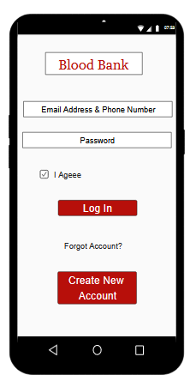

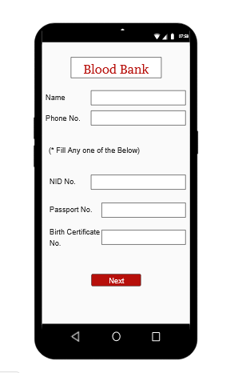

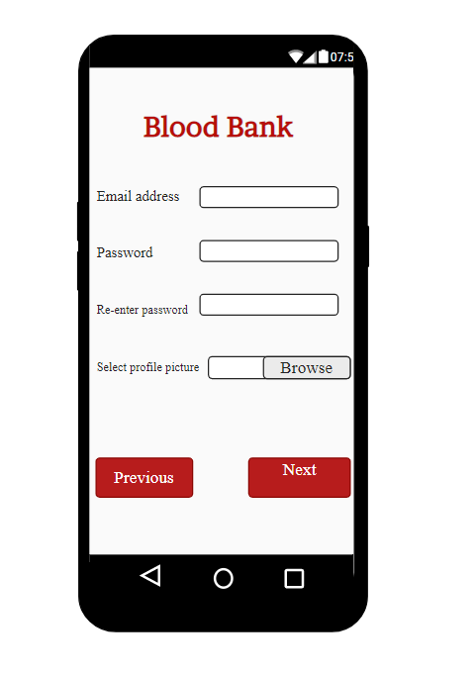

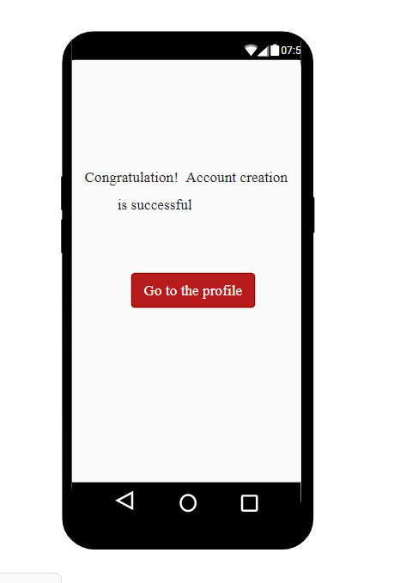

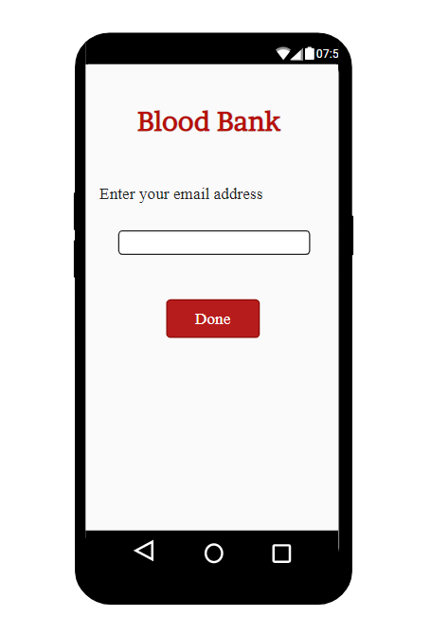

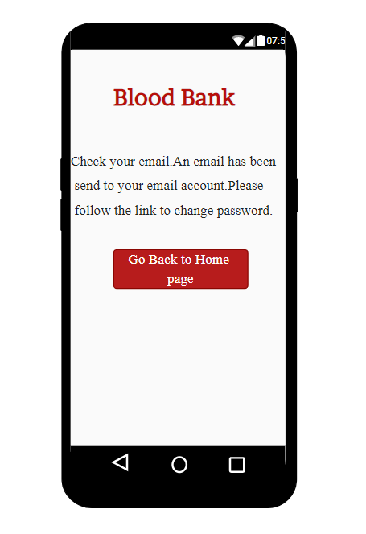

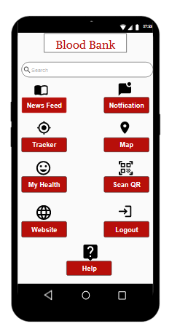

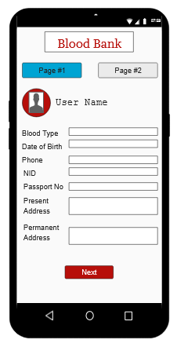

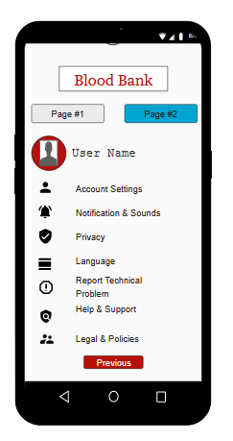

# SYSTEM TEST PLAN

* Select a particular system (Web/Desktop/Mobile/Device) and Identify various modules of the system so that they can be tested stand alone.
* Prepare test cases of testing the selected elements of your identified software.

# PROJECT MANAGEMENT PLAN

## Project Scheduling

|  |  |  |  |
| --- | --- | --- | --- |
| **Task Name** | **Duration** | **Start** | **Finish** |
| A: Overall Design | 1 Month? | Tue 1/7/2020 | 1/8/2020 |
| A.1: Researching users’ requirement |  |  |  |
| A.2: Specifying the input/output media, designing the database. |  |  |  |
| A.3: Planning system implementation. |  |  |  |
| A.4: Devising a test and implementation plan, and specifying any new hardware and software. |  |  |  |
| A.5: Use case diagram, Class Diagram |  |  |  |
| A.6: Activity Diagram, Sequence diagram |  |  |  |
| A.7: Mock Design |  |  |  |
| **B: Integration Testing:** | 20 Days? | 1/8/2020 | 20/8/2020 |
| B.1: testing the interface between two software units or module. |  |  |  |
| B.2: determining the correctness of the interface. |  |  |  |
| B.3: expose faults in the interaction between integrated units |  |  |  |
| **C: System Testing:** | 1 Month? | 20/7/2020 | 10/9/2020 |
| C.1: Create testing environment for the better-quality testing |  |  |  |
| C.2: Generate test case for the testing process |  |  |  |

|  |  |  |  |
| --- | --- | --- | --- |
| C.3: Generate the data that is to be tested. |  |  |  |
| C.4: Execute test cases |  |  |  |
| C.5: Defect Reporting |  |  |  |
| C.6: test the side effects of the testing process |  |  |  |
| C.7: Defects are fixed in this step. |  |  |  |
| C.8: Retest |  |  |  |
| **D: Improving existing system** | 20 days? | 10/9/2020 | 30/9/2020 |
| D.1: Analyzing users’ requirements and suggestions |  |  |  |
| D.2: Creating solutions for existing issues and implementing solutions |  |  |  |
| **E: Coding:** | 20 days? | 25/9/2020 | 5/10/2020 |
| E.1: Running code to test efficiency |  |  |  |
| E.2: Rewriting code to correct errors |  |  |  |
| E.3: Running tests again until code is error free. |  |  |  |
| F: Interaction: |  | 30/7/2020 | 10/10/2020 |
| F.1: Consulting with clients or Project Managers on the progress of developing software to check for possible improvements, suggestions, or requirements |  |  |  |

|  |  |  |  |  |  |  |  |  |  |  |  |  |  |  |  |  |  |  |
| --- | --- | --- | --- | --- | --- | --- | --- | --- | --- | --- | --- | --- | --- | --- | --- | --- | --- | --- |
| **Task:**  **person Weeks** | **1** | **2** | **3** | **4** | **5** | **6** | **7** | **8** | **9** | **10** | **11** | **12** | **13** | **14** | **15** | **16** | **17** | **18** |
| **A:** Shohan |  |  |  |  |  |  |  |  |  |  |  |  |  |  |  |  |  |  |
| **B:** Emon |  |  |  |  |  |  |  |  |  |  |  |  |  |  |  |  |  |  |
| **C:** Ifty |  |  |  |  |  |  |  |  |  |  |  |  |  |  |  |  |  |  |
| **D:** Shohan |  |  |  |  |  |  |  |  |  |  |  |  |  |  |  |  |  |  |
| **E:** Emon |  |  |  |  |  |  |  |  |  |  |  |  |  |  |  |  |  |  |
| **F:** Ifty |  |  |  |  |  |  |  |  |  |  |  |  |  |  |  |  |  |  |

* Identify all the micro tasks related to project management and categorize them within the WBS structure.
* Perform detailed effort estimation correspond with the WBS and schedule
* Draw a Gantt chart of the identified tasks from WBS based on the precedence of each tasks you’ve identified.

## Risk Analysis

* + Describe the available resources and their allocation in performing the project tasks
* Identify all the potential risks in your project development and provide a mitigation plan

**Text Format:**

* Font Style: Times New Roman
* Font Size: 12
* Line space: 1
* Alignment: Justify
* Report Length: Maximum 10 pages